NORTHERN TERRITORY
ROAD SAFETY ANALYSIS
2015–2024
A clear data review using Power BI

Data period: 2015–2024
Primary source: Northern Territory Government – Towards Zero Road Safety
Dashboard platform: Microsoft Power BI

Executive Summary
This report gives a simple overview of road safety in the Northern Territory from 2015 to 2024. Over the ten-year period, 419 people died on NT roads in 360 fatal crashes. The dashboard shows that the problem is not evenly distributed: rural locations account for nearly three-quarters of fatalities, drivers and passengers make up the largest road-user groups, and alcohol is the most frequently recorded selected contributing factor. [1]
The yearly results also change sharply from one year to another. This means the long-term pattern is more useful than judging road safety from one year alone. The demographic page adds further context by showing that males and people aged over 25 make up the larger shares of recorded fatalities. Road-surface results are also included, but they are interpreted carefully because the data does not show how much traffic uses each surface type.
For national context, the NT recorded a 2024 fatality rate of 23.0 deaths per 100,000 population, compared with about 4.7 nationally. This indicates that the NT road-safety burden remains high even after population size is considered. [2]

1. Introduction
The Northern Territory has a large road network that includes urban, rural and remote travel. This report uses official road-safety statistics and Power BI visuals to make the main patterns easy to see and explain. The focus is on fatalities, fatal crashes, road-user groups, contributing factors, location, demographics and road-surface conditions.
The aim is not only to show the numbers, but also to explain what the patterns may mean and where caution is needed when interpreting them.

2. Data Source and Method
The main data source is the Northern Territory Government Towards Zero road-safety statistics. The figures are based on NT Police crash reports and can be updated as records are investigated and validated. The public data is aggregated, so this report analyses groups and yearly totals rather than individual crashes. [1]
The data was organised for Power BI using a yearly summary table for the headline measures and a long-format table for categories such as road user, contributing factor, location and demographic group. A Year slicer allows the dashboard to focus on a selected year or range of years.
One important limitation is the 2024 serious-injury figure. The published total is 61, much lower than previous years. The official value is kept in the report, but it should be treated cautiously rather than interpreted as a sudden improvement.

3. Overall Road Safety Picture
Metric | 2015–2024 total | Average per year | Simple meaning
Fatalities | 419 | 41.9 | People who died on NT roads
Fatal crashes | 360 | 36.0 | Crashes involving at least one fatality
Serious injuries | 4,113 | 411.3* | Published serious-injury count
Serious-injury crashes | 3,216 | 321.6* | Crashes involving serious injury
*The serious-injury averages include the unusually low published 2024 figures and should be interpreted with caution.
Figure 1. Headline road-safety indicators for 2015–2024.
At first glance, the headline figures show that fatal crashes and fatalities are close in size: 360 fatal crashes resulted in 419 deaths. This indicates that some fatal crashes involved more than one death. The serious-injury totals are much larger, showing that the effect of road trauma extends well beyond fatalities alone.

4. Fatality Trend Over Time
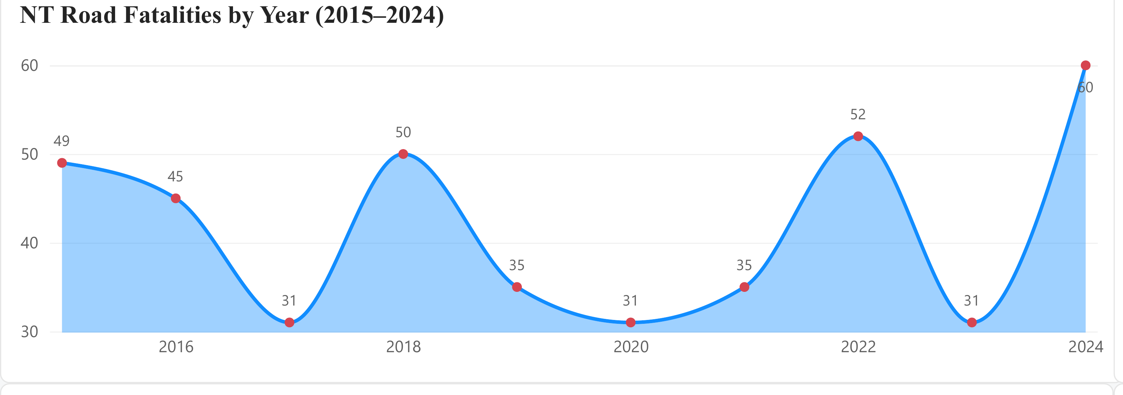
Figure 2. NT road fatalities by year, 2015–2024.
The line does not show a steady improvement or a steady decline. Instead, fatalities rise and fall sharply across the decade. The repeated low point of 31 deaths in 2017, 2020 and 2023 is followed by higher totals in other years, including 52 in 2022 and 60 in 2024. [1]
The main message is that a single good year does not necessarily mean the underlying road-safety problem has been solved. The rebound after lower years shows why several years should be considered together when discussing progress.

5. Road User Analysis
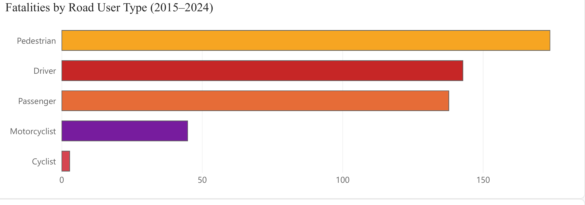
Figure 3. Fatalities by road-user type, 2015–2024.
Drivers and passengers together account for 281 of the 419 fatalities, or about two-thirds of the total. This makes vehicle occupants the largest group in the dataset. Pedestrians also form a substantial group with 90 deaths, while motorcyclists and cyclists have smaller counts. [1]
This pattern suggests that road-safety attention cannot focus on only one type of road user. Occupant safety remains central because drivers and passengers dominate the total, but pedestrian risk is also large enough to require separate attention rather than being treated as a minor issue.

6. Key Contributing Factors
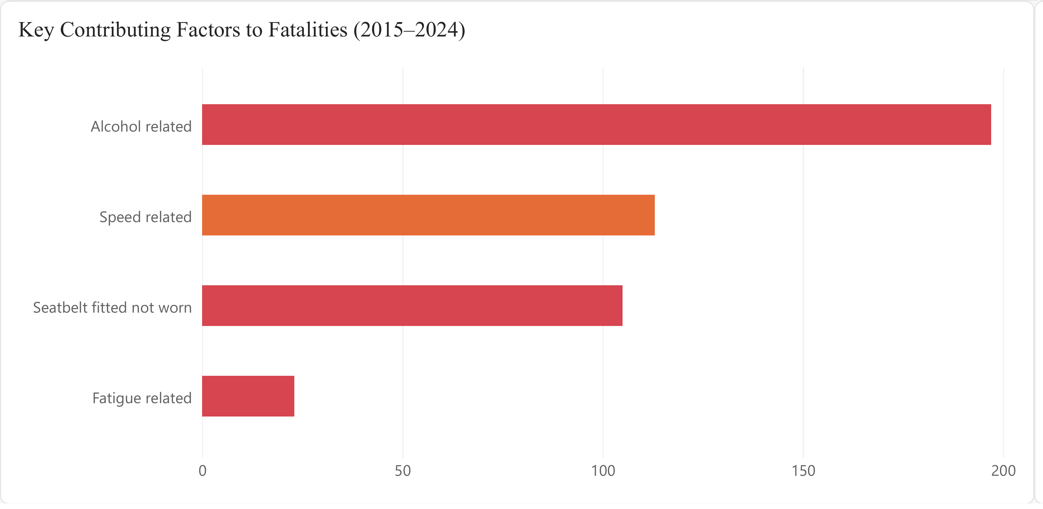
Figure 4. Selected contributing factors associated with fatalities.
Alcohol is the most frequently recorded selected factor, appearing in 197 fatalities. Speed and seatbelt non-use are also prominent, while fatigue is recorded less often in this selected group. [1]
The useful point is not to add these bars together, because more than one factor can be present in the same crash. Instead, the chart highlights recurring behaviours that appear alongside fatal outcomes. Alcohol standing clearly above the other selected factors makes impairment an especially important pattern in the data.

7. Rural and Urban Fatalities
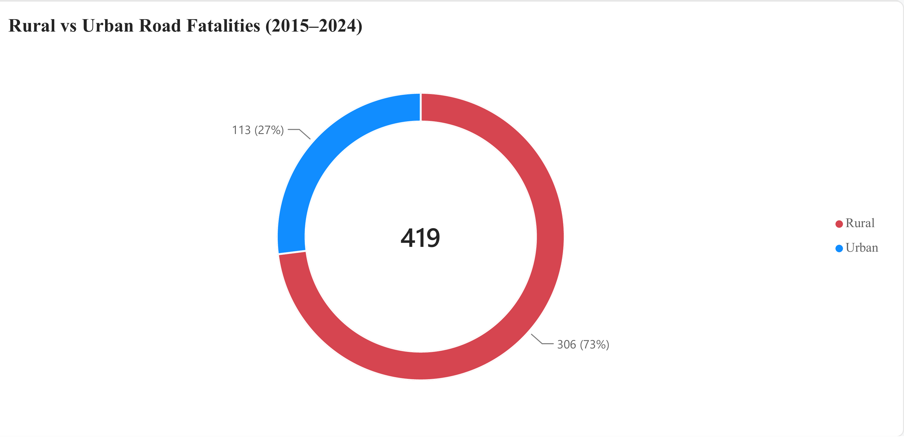
Figure 5. Rural versus urban road fatalities, 2015–2024.
Rural locations account for 306 fatalities, compared with 113 in urban locations. In other words, almost three out of every four recorded fatalities occurred outside the urban category used in the NT dataset. [1]
This is one of the strongest patterns in the report. It shows where the fatality burden is concentrated, but it does not by itself explain why. Travel distance, road design, speed, traffic volume and emergency response may all be relevant, but those factors would need additional data before a cause could be claimed.

8. Fatalities by Sex
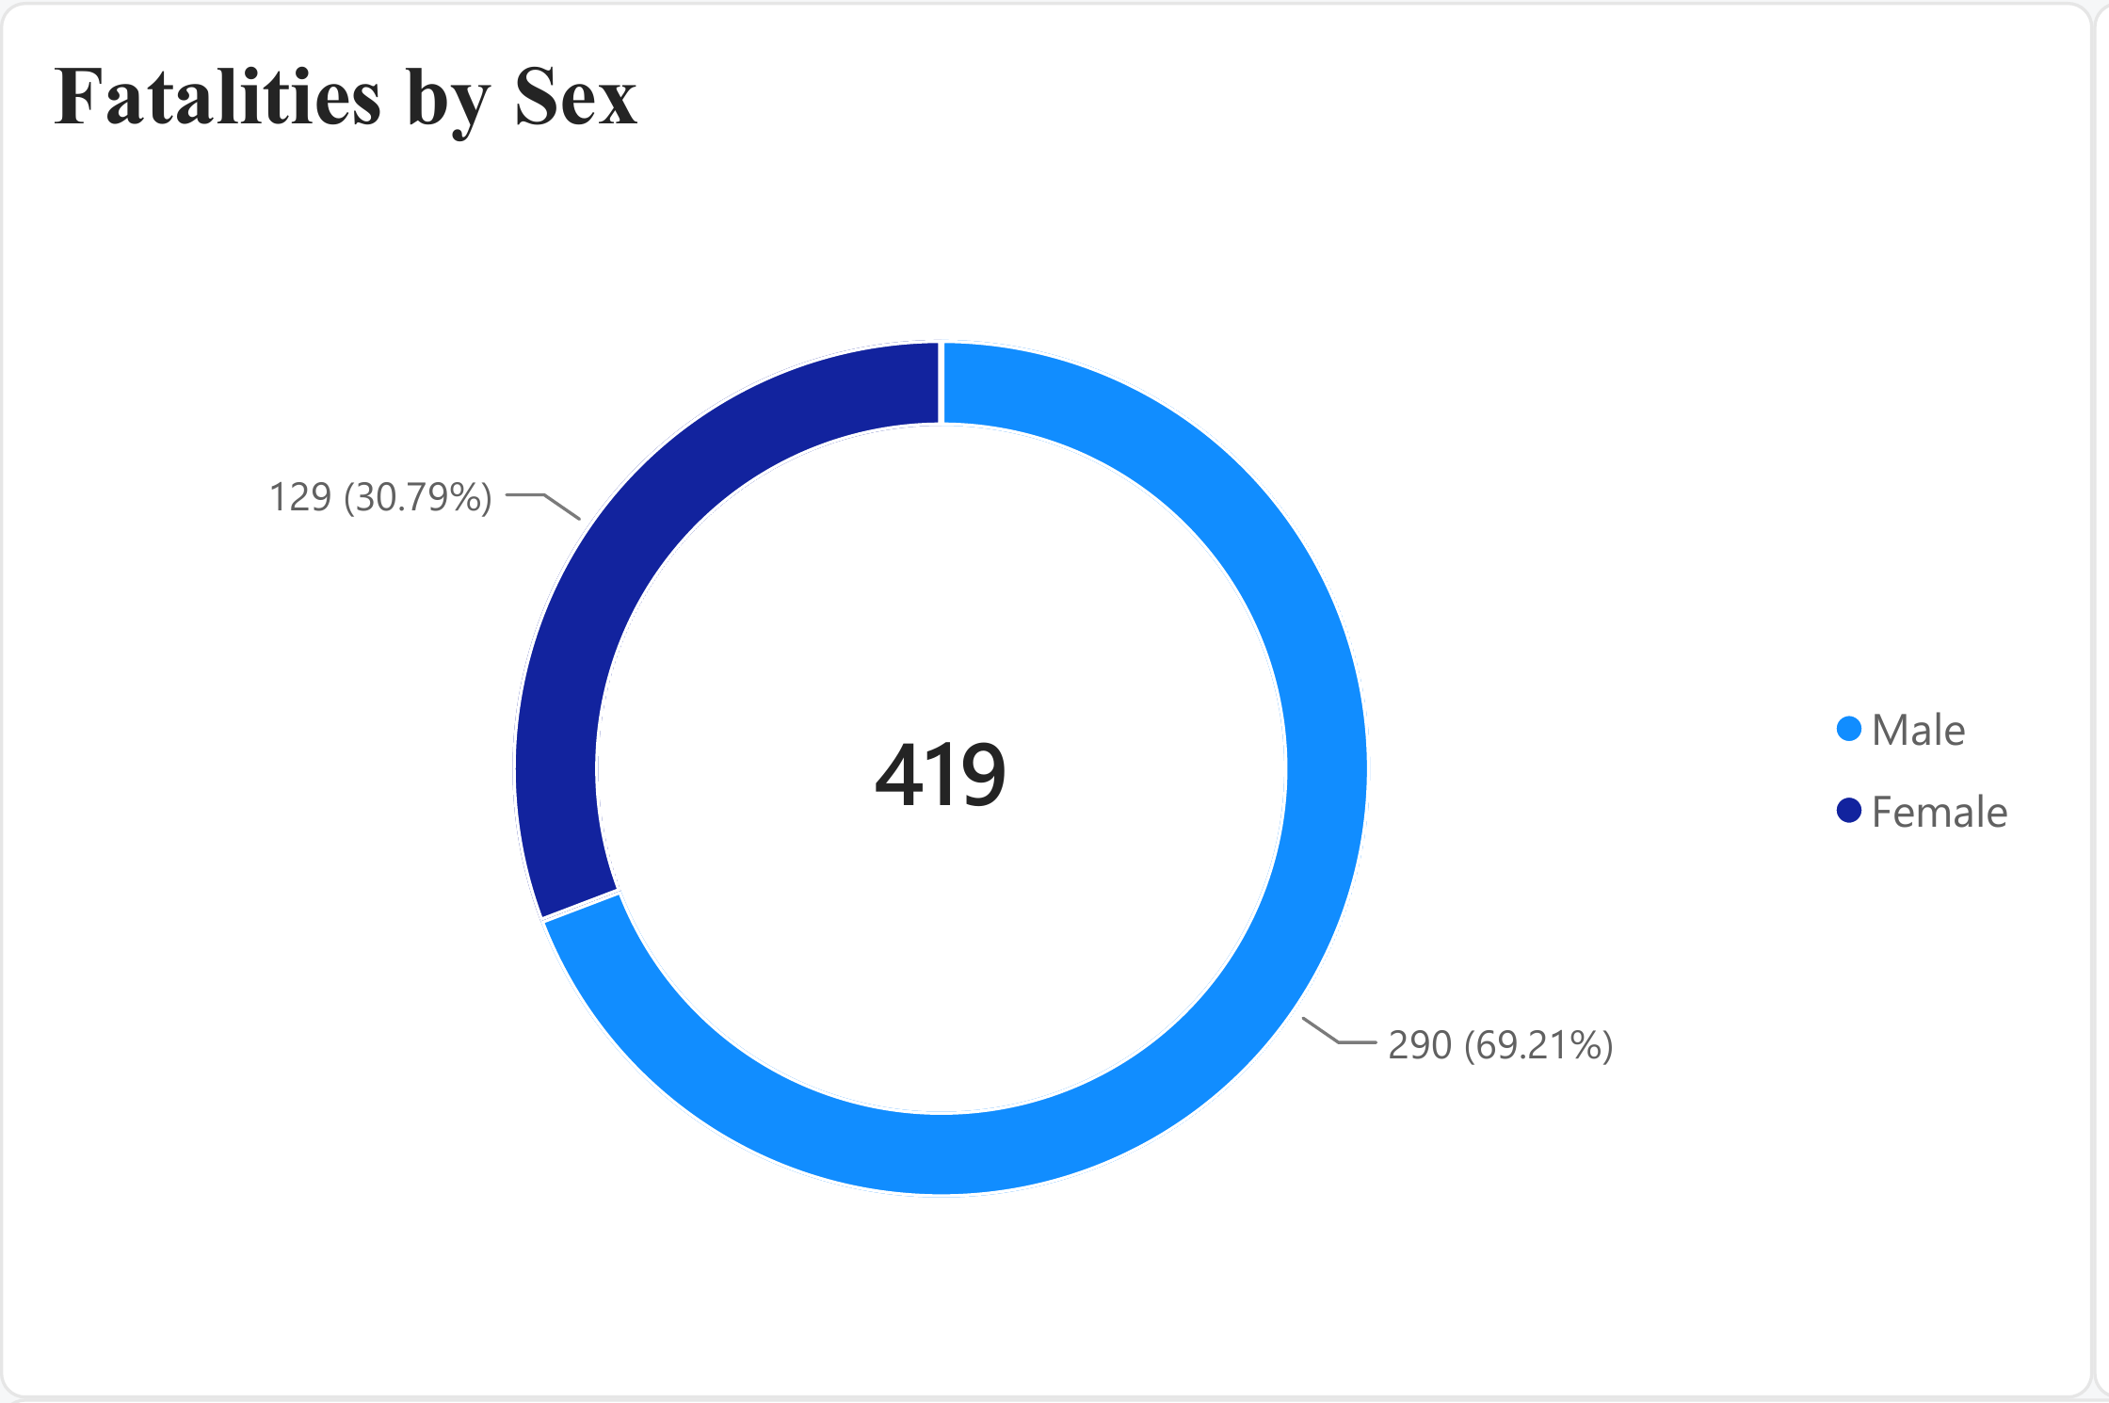
Figure 6. Fatalities by sex.
Males represent just over two-thirds of recorded fatalities. The difference is large enough to be a clear demographic pattern rather than a small variation between groups.
However, the dashboard does not include information such as kilometres travelled, driving frequency or time spent on the road. The chart therefore shows who is more represented in the fatality count, not that sex itself causes the higher risk.

9. Fatalities by Age Group
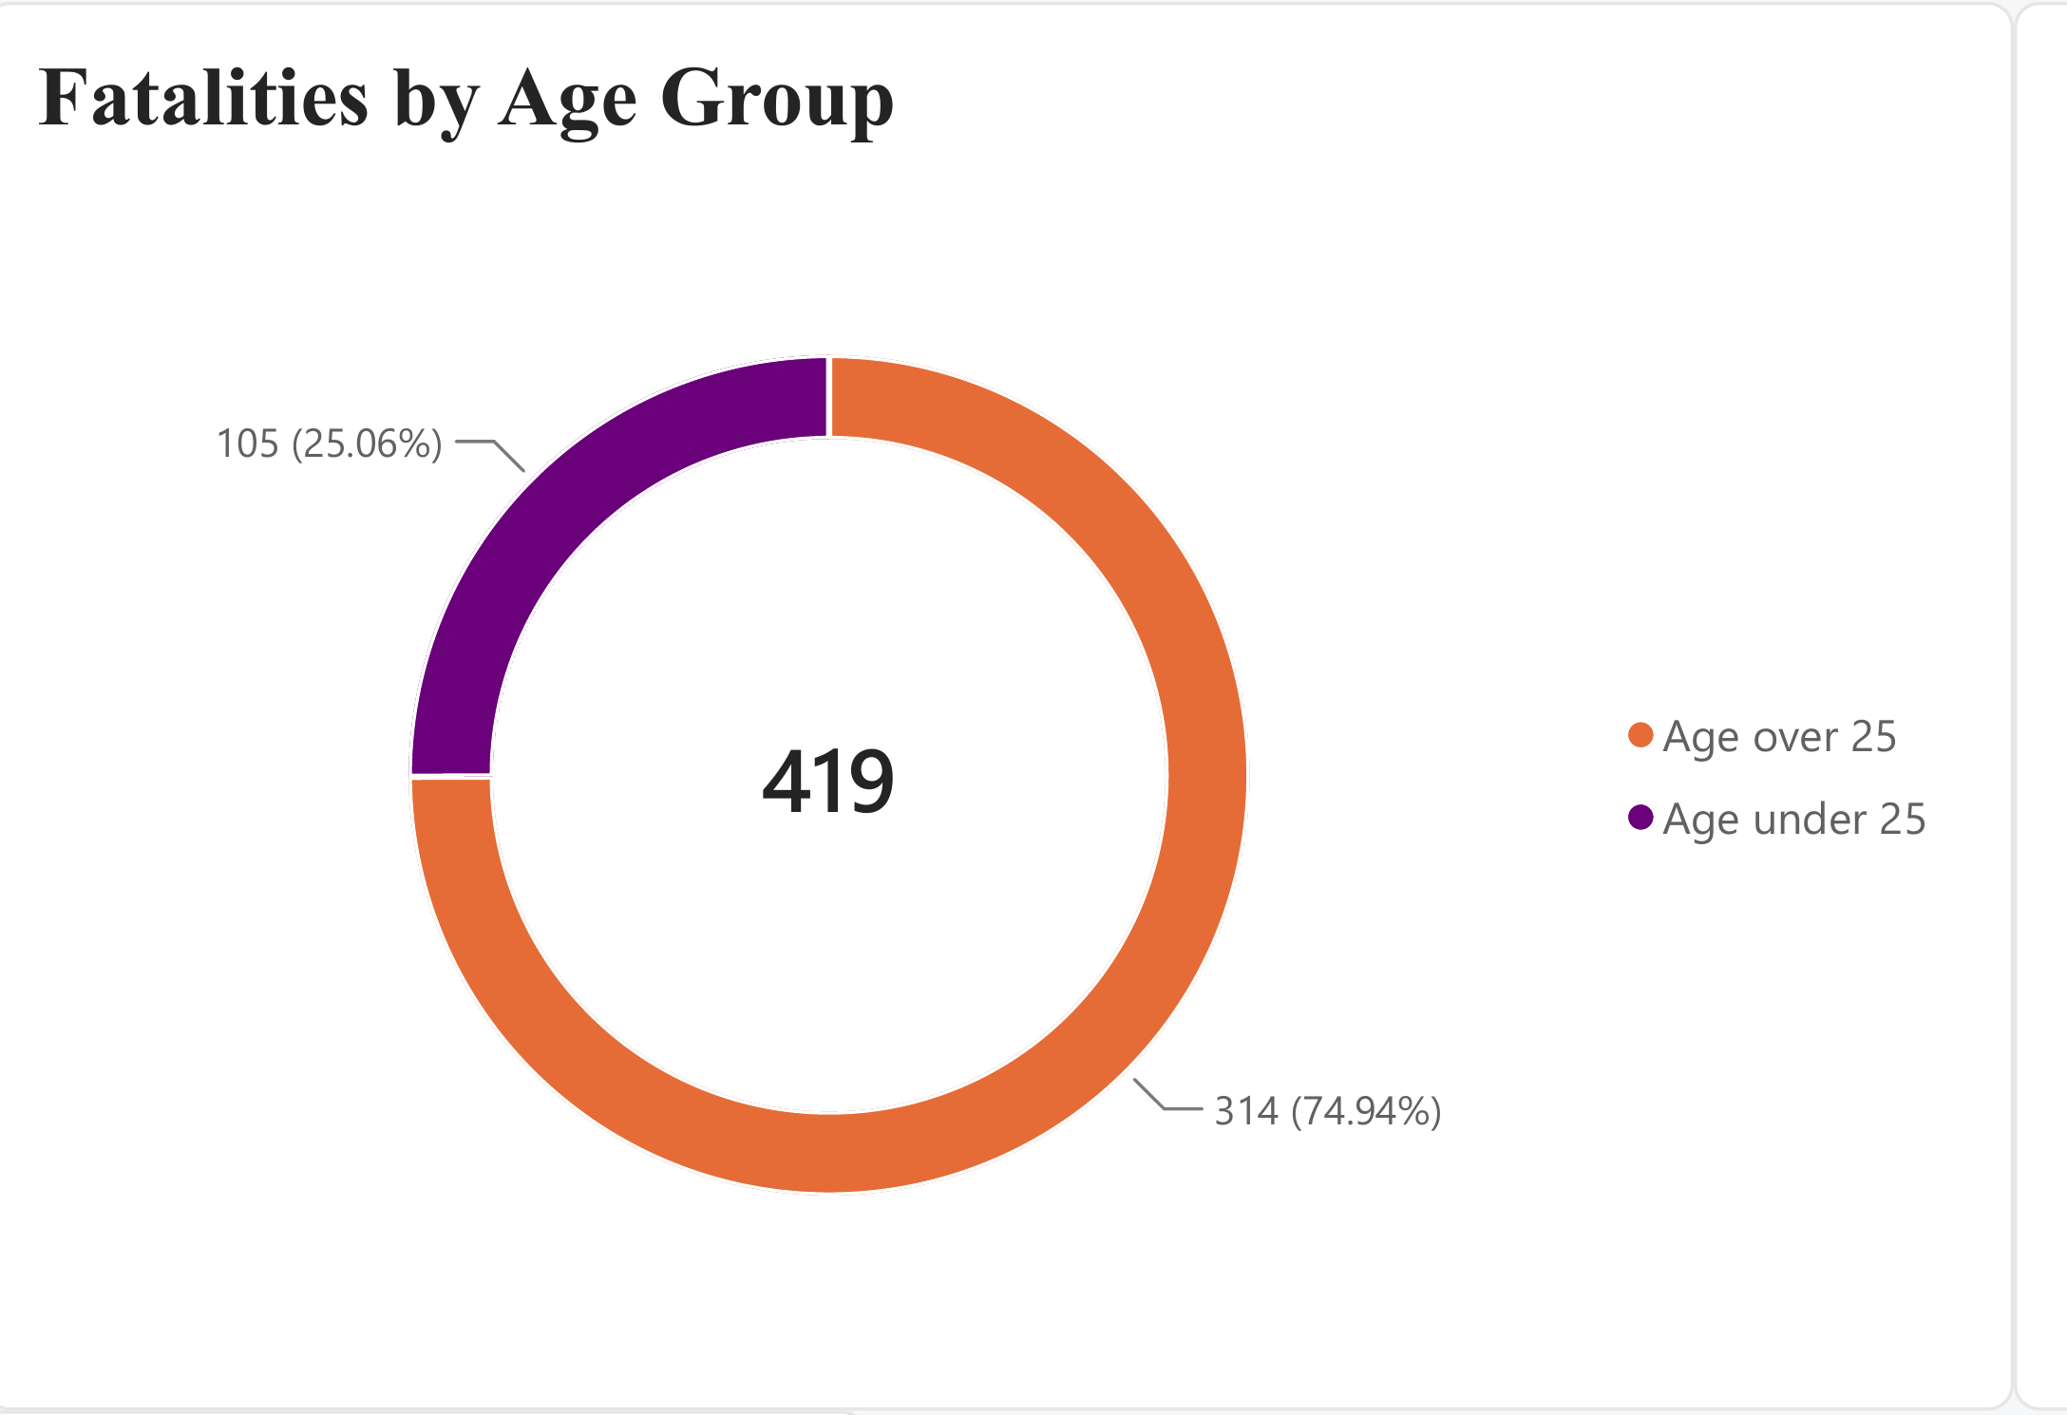
Figure 7. Fatalities by age group.
People aged over 25 account for about three-quarters of recorded fatalities. This means the total road-safety burden is not concentrated only among younger road users.
The age categories are broad, so this chart is best used as a simple overview. A more detailed age breakdown would be needed to identify whether particular adult age groups carry a higher burden.

10. Aboriginal Status
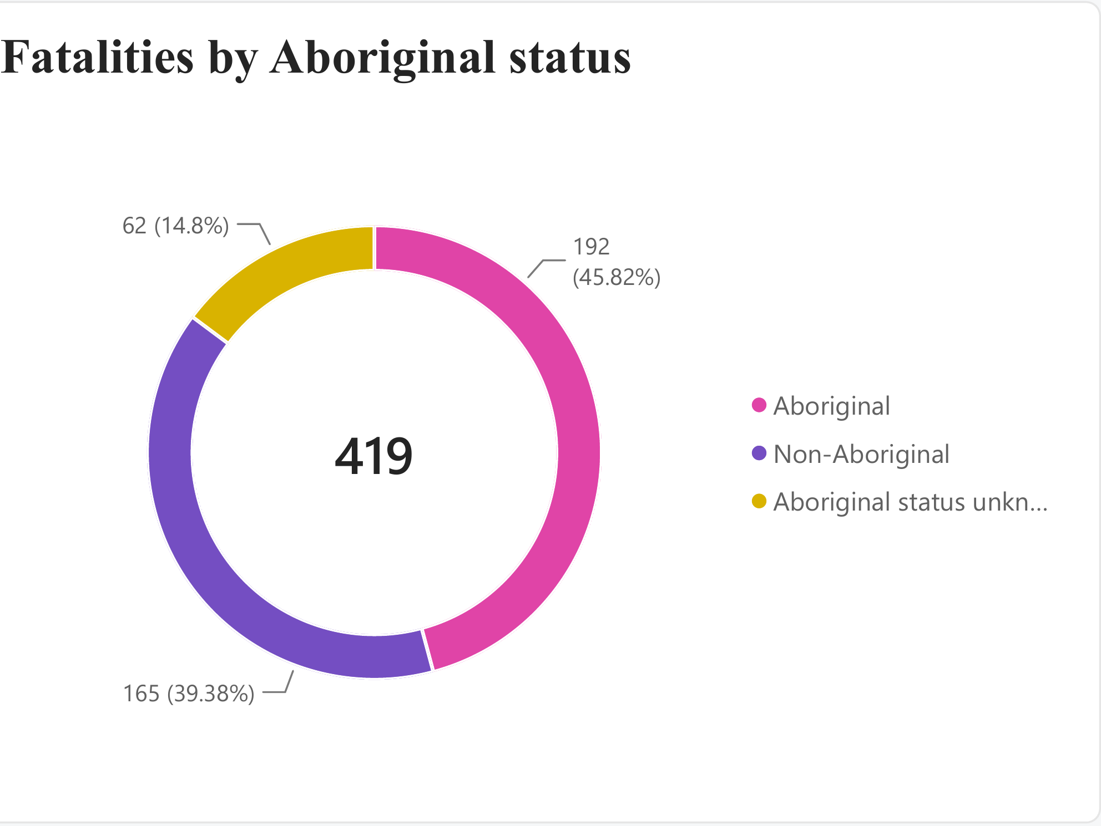
Figure 8. Fatalities by Aboriginal status.
The dashboard records 192 Aboriginal fatalities, 165 Non-Aboriginal fatalities and 62 where Aboriginal status is unknown. The unknown group is important because removing it would give an incomplete picture of the total.

11. Road-Surface Conditions
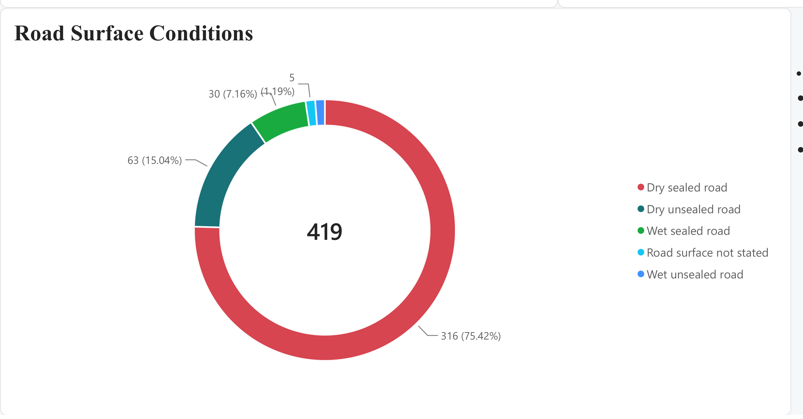
Figure 9. Road-surface conditions recorded for fatalities.

Most fatalities in the dataset were recorded on dry sealed roads, with 316 fatalities during 2015–2024. This represents approximately 75% of the 419 fatalities recorded over the period. Dry unsealed roads accounted for 63 fatalities, while wet sealed roads accounted for 30. Only a small number were recorded on wet unsealed roads or where the road-surface condition was not stated.
At first glance, the high number of fatalities on dry sealed roads may suggest that these roads are more dangerous than other surface types. However, this conclusion cannot be made from the fatality counts alone. The dataset shows the surface condition associated with fatalities, but it does not provide information about the amount of traffic or distance travelled on each type of road.
For example, if most vehicles in the Northern Territory travel on sealed roads, it would naturally be expected that a larger number of crashes and fatalities would also occur on those roads. Therefore, the number of fatalities should not be interpreted as a direct measure of the risk associated with each road-surface type.

12. Main Insights at a Glance
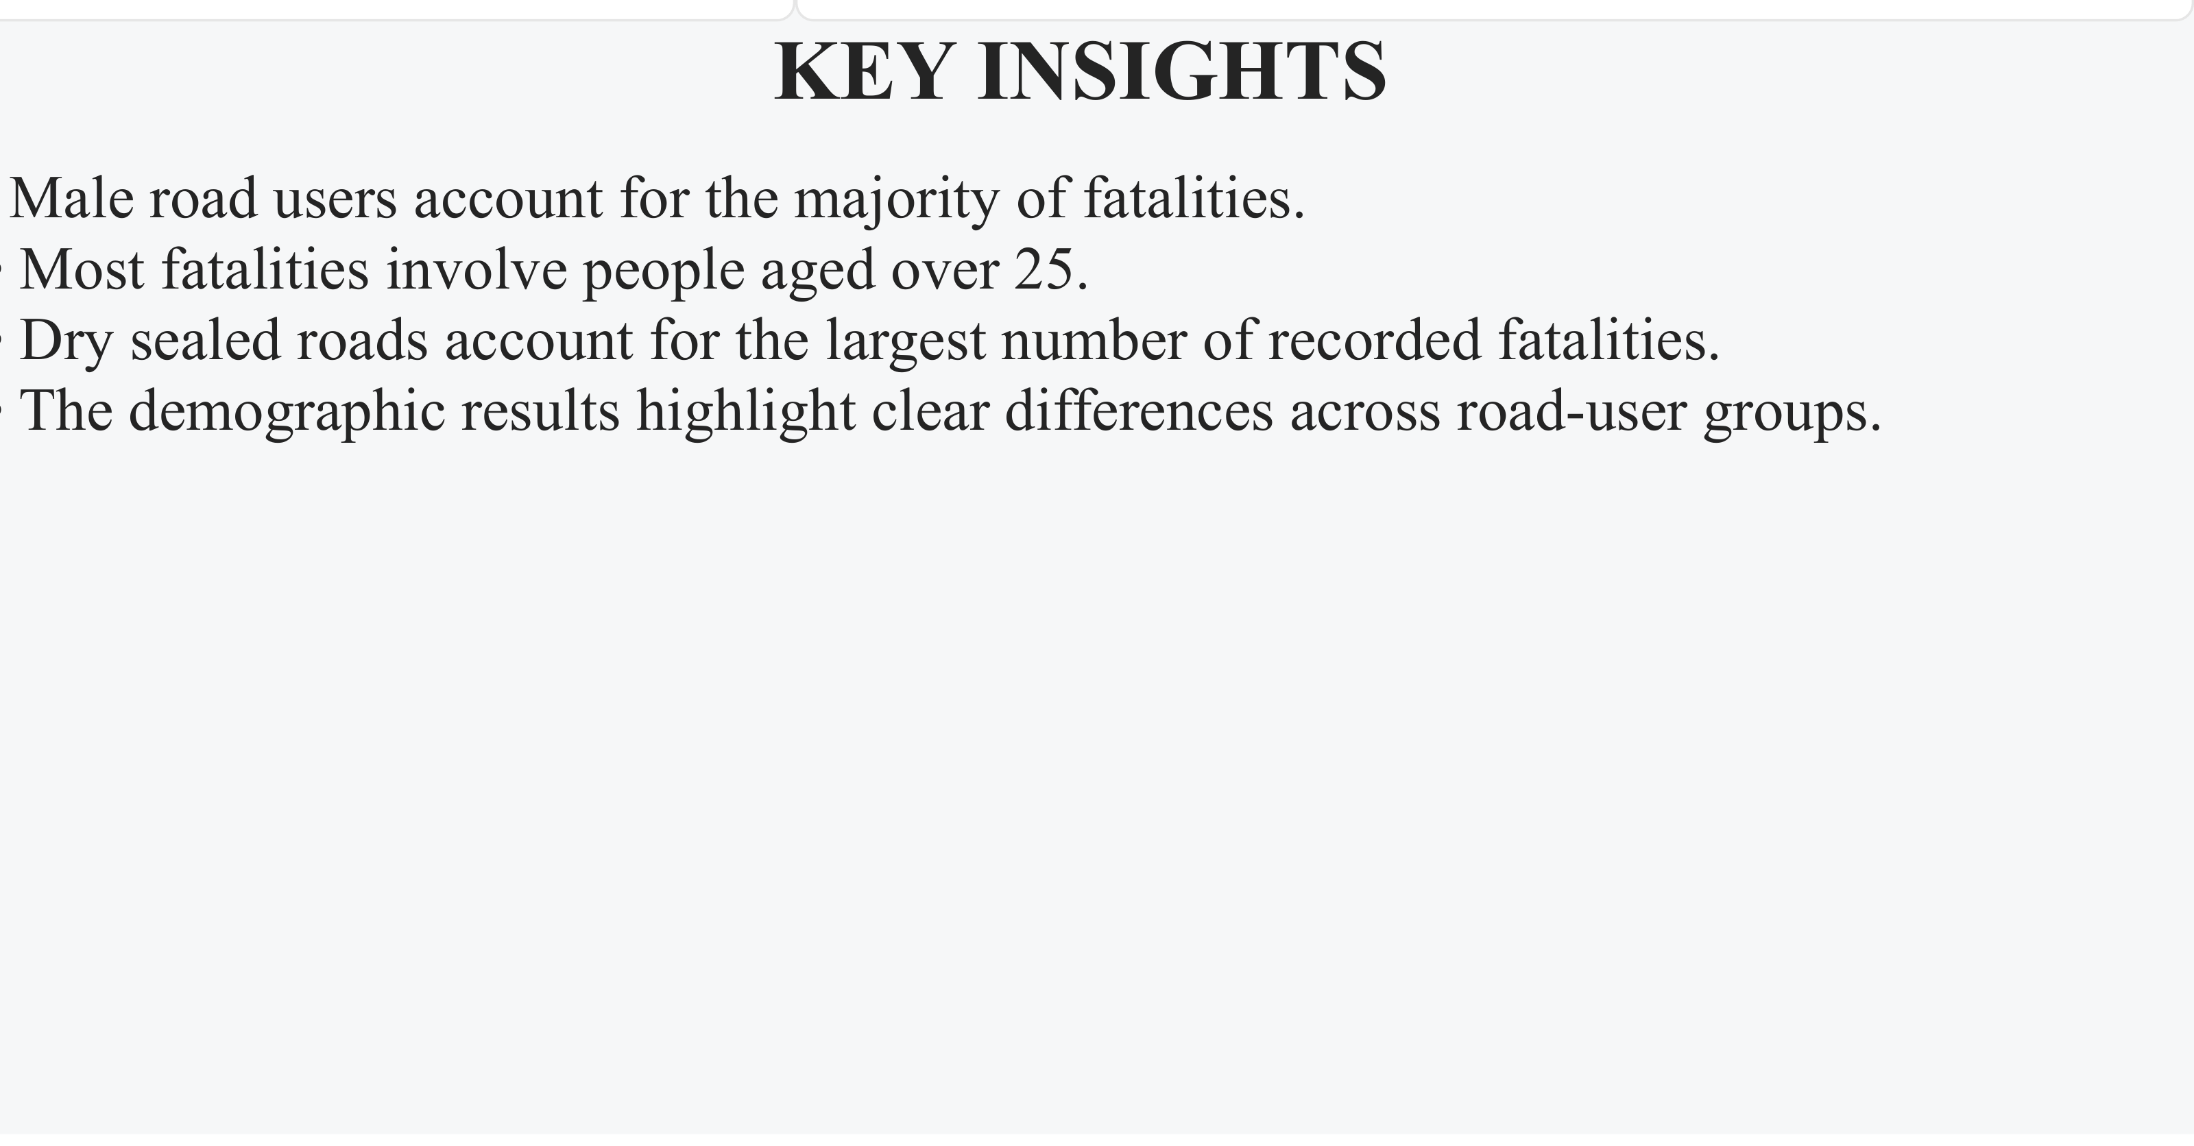
Figure 10. Key Insights panel from the dashboard.
- Road fatalities vary considerably from year to year, so the long-term trend is more useful than one annual result.
- Vehicle occupants make up the largest share of fatalities, while pedestrian deaths also remain substantial.
- Alcohol is the strongest selected contributing-factor pattern in the data.
- Rural locations account for nearly three-quarters of fatalities, making location one of the clearest differences in the dataset.
- Males and people aged over 25 make up the larger demographic shares, but exposure data is needed before making risk claims.
- Most fatalities are recorded on dry sealed roads, but surface-specific traffic exposure is not available.

13. NT Compared with Australia
Raw death totals are not the fairest way to compare the NT with larger states because their populations are very different. A better comparison is the number of road deaths per 100,000 people.
In 2024, the National Road Safety Data Hub reported a fatality rate of 23.0 per 100,000 population for the NT, compared with about 4.7 nationally. The next-highest state or territory rate was Western Australia at 6.3. [2]
This comparison is important because it shows that the NT result is not simply high because of the number of people living there. Even after population size is taken into account, the NT rate is almost five times the national rate and more than three times the rate of any other jurisdiction in 2024. [2]
Data note: the national Annual Trauma table reports 58 NT road deaths for 2024, while the NT-specific Towards Zero source reports 60. The difference reflects separate reporting and validation processes, so this report uses the national source consistently for national comparison and the NT source for the NT-specific dashboard.

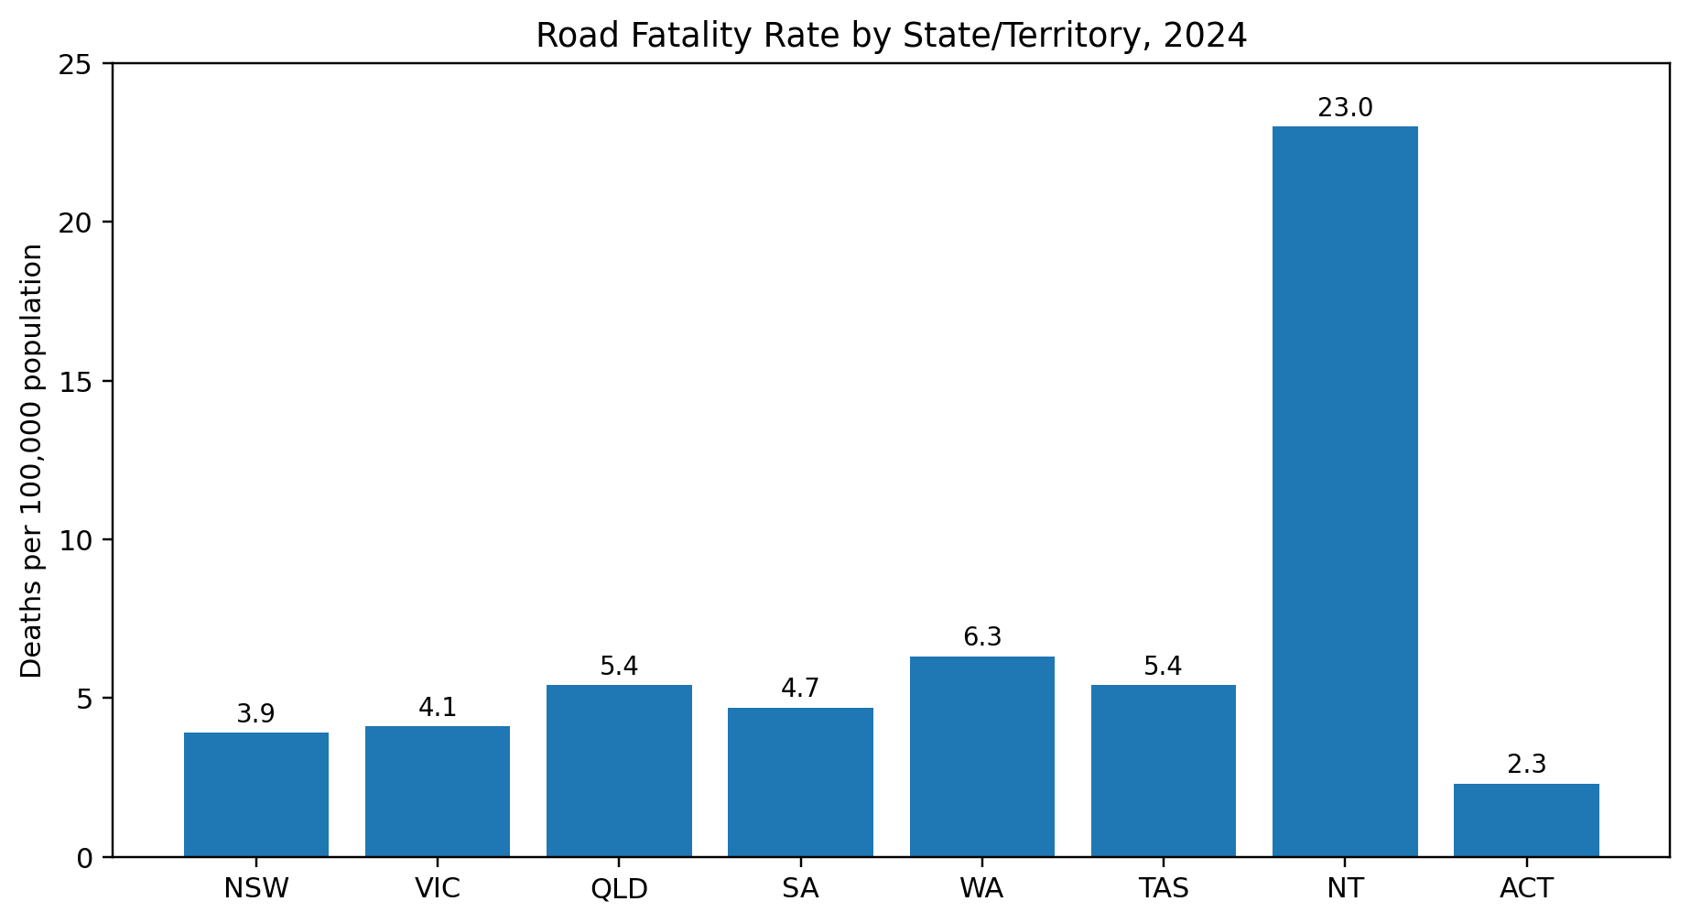14. Dashboard Design and Data Story
The dashboard is arranged so the main message can be understood quickly. Page 1 starts with the headline totals, then moves through the yearly trend, road users, contributing factors and location. Page 2 adds demographic and road-surface context.
This order makes the report easier to explain: first, how large is the problem; second, how has it changed; third, who is affected; fourth, what factors appear with fatalities; and finally, where and under what recorded conditions do fatalities occur. The visuals support the explanation rather than simply repeating the same information in different formats.

15. Report Maintenance
The Power BI semantic model is connected to the Excel source stored in OneDrive/SharePoint. A daily refresh is configured for 8:00 AM Darwin time, and refresh-failure notifications are enabled. This allows updated source data to flow into the report without rebuilding the dashboard each time.
For future maintenance, the source location, table names and metric definitions should remain consistent. After any source change, the refresh history and main dashboard totals should be checked to confirm that the report still behaves as expected.

16. Limitations
- The public data is aggregated, so individual crash circumstances cannot be analysed.
- Contributing factors can overlap and are not separate causes that can be added together.
- The 2024 serious-injury figures are unusually low and should be treated cautiously.
- Demographic counts do not include travel exposure, so they describe representation rather than individual risk.
- Road-surface counts do not include traffic volume or kilometres travelled on each surface.
- Official road-safety figures may change as records are validated.

17. Conclusion
The clearest message from the 2015–2024 data is that NT road trauma is unevenly distributed. Rural fatalities dominate the location pattern, drivers and passengers make up the largest road-user share, and alcohol is the most frequently recorded selected contributing factor. The annual fatality count also changes sharply, showing why long-term trends are more informative than a single year. [1]
The demographic and road-surface visuals add useful context, but they also show why counts need careful interpretation. A large share does not automatically mean a category causes greater risk. When the NT is compared with Australia using population-adjusted rates, the size of the road-safety challenge becomes especially clear: the NT rate in 2024 was far above the national rate. [2]

References
[1] Northern Territory Government, Towards Zero – Road Safety. “Lives lost on NT roads.” Data derived from NT Police crash reports. https://roadsafety.nt.gov.au/research-and-statistics/lives-lost-nt-roads (accessed 15 September 2026).
[2] Australian Government, National Road Safety Data Hub, “Annual trauma” and “Monthly road deaths”. https://datahub.roadsafety.gov.au/reporting/annual-trauma and https://datahub.roadsafety.gov.au/reporting/monthly-road-deaths (accessed 15 September 2026).

Appendix A – Final Power BI Dashboard
The complete dashboard pages are included here for reference. In the main report, each visual is shown separately beside its explanation.
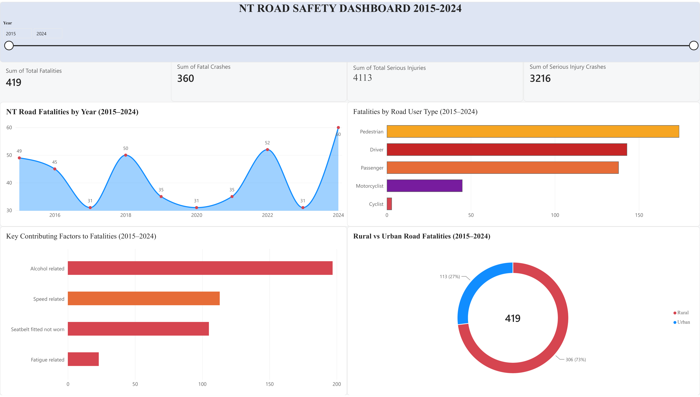
Appendix Figure A1. Final Dashboard Page 1 – NT Road Safety Dashboard 2015–2024.

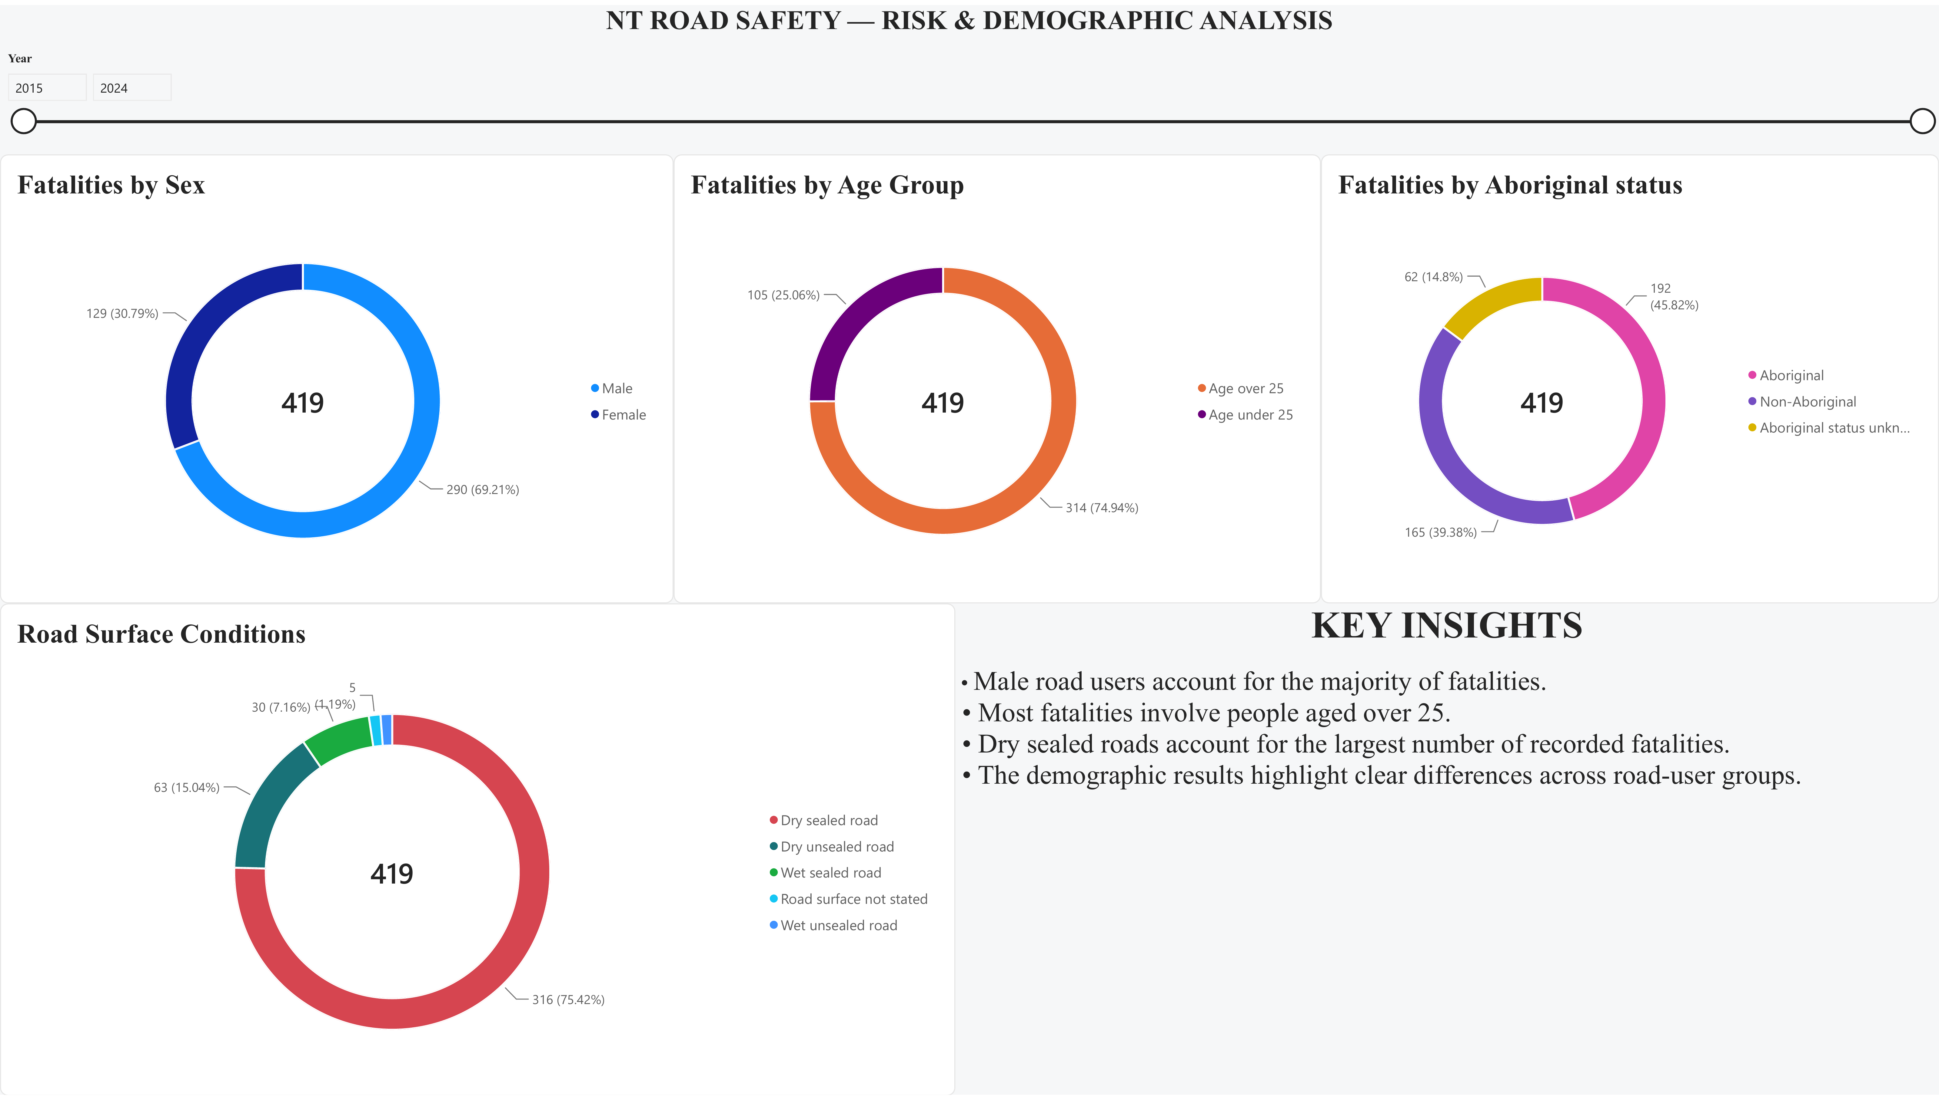
Appendix Figure A2. Final Dashboard Page 2 – Risk & Demographic Analysis.

Appendix B – Power BI Report Maintenance Evidence
The following screenshots show the report sharing, refresh and cloud-connection settings used to maintain the published Power BI report.

Appendix Figure B1. Power BI sharing interface.
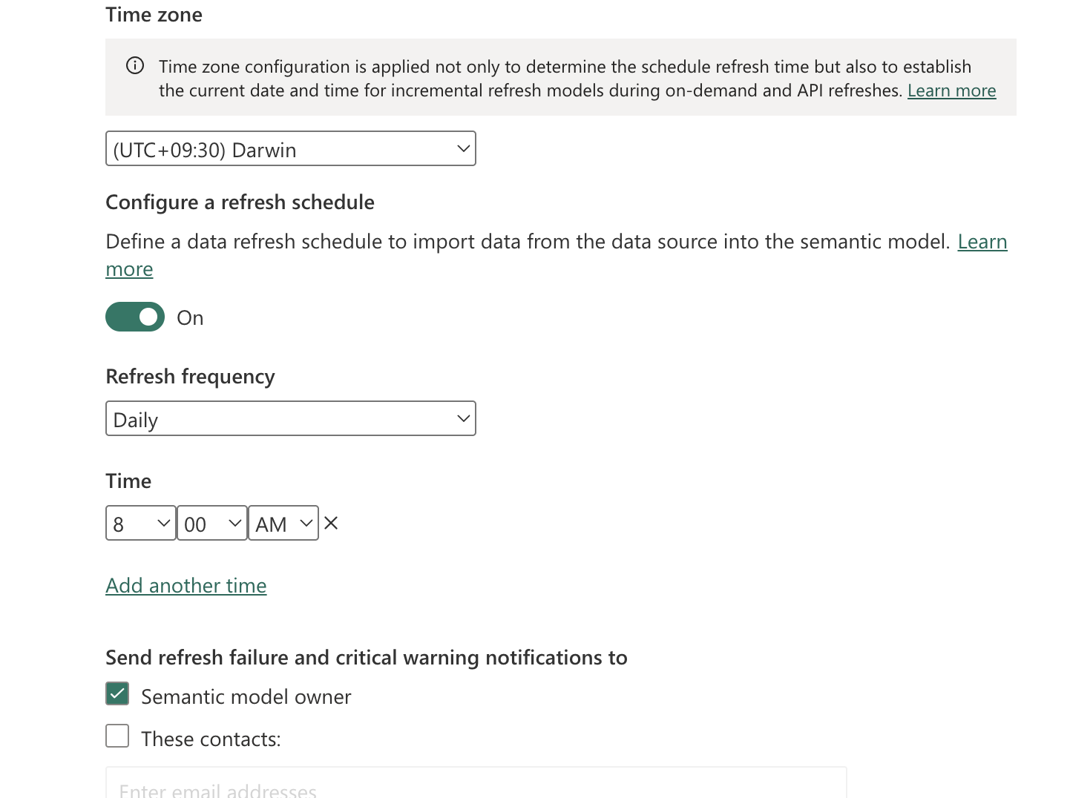
Appendix Figure B2. Daily scheduled refresh at 8:00 AM Darwin time.

Appendix Figure B3. Cloud connection configuration for the semantic model.

